Week 7

1)
// Write a generic method to exchange the positions of two different elements in an array.

import java.util.Arrays;
import java.util.List;

class Generics{
public static final <T> void swap(T[] a, int i, int j) {
T t = a[i];
a[i] = a[j];
a[j] = t;
}

public static void main(String[] args){
String [] a = {"First", "Second"};
System.out.println("Before Swapping");
System.out.println("a:" + Arrays.toString(a));
swap(a, 0, 1);
System.out.println("After Swapping");
System.out.println("a:" + Arrays.toString(a));
Integer [] b = {1, 2};
System.out.println("Before Swapping");
System.out.println("b:" + Arrays.toString(b));
swap(b, 0, 1);
System.out.println("After Swapping");
System.out.println("b:" + Arrays.toString(b));
}
}
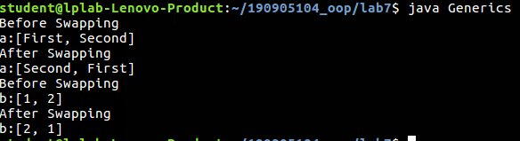

2)

// Define a simple generic stack class and show the use of the generic class
// for two different class types Student and Employee class objects.

import java.lang.reflect.Array;

class PushException extends Exception{
private int code;

public PushException(int c){
this.code = c;
}
public int getCode(){
return code;
}
}

class PopException extends Exception{
private int code;
public PopException(int c){
this.code = c;
}
public int getCode(){
return code;
}
}

class Stack<T>{
private T item[];
private int top;
private int size;
public Stack(Class<T[]> obj, int length){
this.size = length;
this.item = obj.cast(Array.newInstance(obj.getComponentType(), length));
this.top = -1;
}

public boolean isEmpty(){
if(this.top == -1) return (true);
return (false);
}

public boolean isFull(){
if(this.top == this.size -1)
return (true);
return (false);
}

public boolean push(T elem) throws PushException{
if(this.isFull()){
throw new PushException(1);
}
this.item[++this.top] = elem;
return (true);
}
public T pop() throws PopException{
if(this.isEmpty()){
throw new PopException(-1);
}

return(this.item[this.top--]);
}
public void display(){
if(this.isEmpty())
return;
for(int i = 0; i < this.top + 1; i++){
System.out.println(this.item[i]);
}
System.out.println("");
}
}

class Student{
String name; int reg_no;
Student(String name, int reg_no){
this.name = name;
this.reg_no = reg_no;
}

}
class Employee
{
String name;
int emp_no;
Employee(String name, int emp_no){
this.name = name;
this.emp_no = emp_no;
}
}

class StackTest{
public static void main(String[] args) {
System.out.println("Creating stack object for Student with size 3");
Stack<Student> s1 = new Stack<Student>(Student[].class, 3);
System.out.println("Creating stack object for Employee with size 3");
Stack<Employee> s2 = new Stack<Employee>(Employee[].class, 3);
System.out.println("Displaying student stack");
try{
System.out.println("Pushing elements to student stack");
s1.push(new Student("Mohan", 123));
s1.push(new Student("Rohan", 456));
s1.push(new Student("Sohan", 789));
System.out.println("Displaying student stack");
s1.display();
System.out.println("Pushing elements to employee stack");
s2.push(new Employee("Ram", 12));
s2.push(new Employee("Shaam", 34));
s2.push(new Employee("Gyaan", 56));
System.out.println("Displaying employee stack");
s2.display();
}catch(PushException e){
System.out.println("Caught exception: " + e);
} // no exceptions caught

try{
System.out.println("Pushing element to an already filled student stack");
s1.push(new Student("Soham", 967));
System.out.println("Displaying student stack");
s1.display();
}catch(PushException e){
System.out.println("Caught exception: " + e);
} // exception caught
}
}

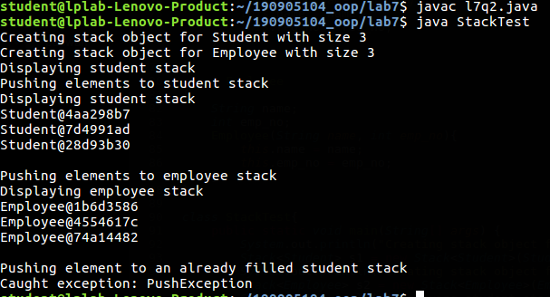

3)

// Write a program to demonstrate the use of wildcard arguments.

import java.util.Arrays;
import java.util.List;

class WildcardDemo {

private static void printlist(List<?> list){
System.out.println(list);
}

public static void main(String[] args){
List<Integer> list1 = Arrays.asList(1, 2, 3);
List<String> list2 = Arrays.asList("First", "Second", "Third");
printlist(list1);
printlist(list2);
}
}

